Fmr Hamilton Hill Post Office | C | Significant
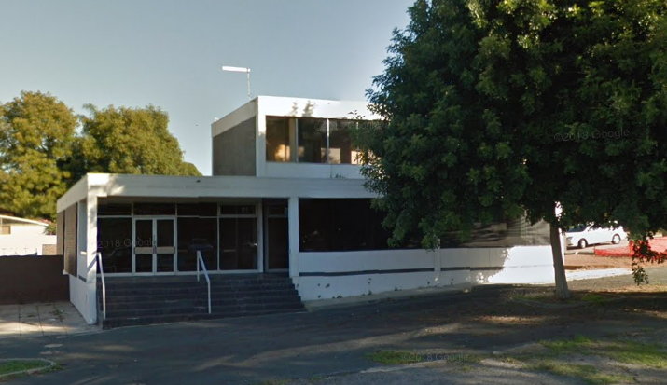
LGI # | XX
PIN No.
LOT/PLAN DIAGRAM
LOCATION | 5 Dodd Street, Hamilton Hill
OTHER NAME(S) | -----
CONSTRUCTION DATE(S) | 1969
STATEMENT OF SIGNIFICANCE
The former Hamilton Hill Post Office has some historic value as a reminder of Hamilton Hill’s growth during the 1960s and 1970s.

The former Hamilton Hill Post Office has historic value as part of extensive WA Post Office telecommunications expansion and building works during the 1960s in response to increased demand for postal services.

The former Hamilton Hill Post Office has some landmark value located on a corner site within the Simms Road neighbourhood centre.

PHYSICAL DESCRIPTION
The former Hamilton Hill Post Office is a two-storey brown brick and concrete building constructed in 1969 by the WA Post Office.
A physical assessment of the former Post Office, and reference to Apperley, Irving and Reynolds’ Identifying Australian Architecture: Styles and Terms from 1788 to the Present, (1989) determines that the building demonstrates more characteristics of the Late Twentieth-Century International style.
These include a cubiform shape; the structural frame expressed; large sheets of glass; plain, smooth wall surfaces; a precision and sharpness, whether free standing or to the façade; and contrasting textures (concrete and brick). Some of these characteristics are also demonstrated in Brutalism, but the latter is much more focused on the use of concrete, and the expression of large, aggressive, blocky forms.
Although setback from the street and disjointed from the commercial buildings on Simms Road, the building does have some landmark value sited on the corner of Dodd Street and Straughair Street. Early photographs (see figures 2 and 3) demonstrate this more successfully, as there were no mature trees to soften the streetscape.
The exterior of the building remains in original condition.
The building is sited on the corner of Dodd Street and Straughair Street, and although setback from the street it does have some landmark value.
There is a large mature tree within the adjacent road reserve that appears likely to have been planted at the time the post office was built.

HISTORY
The former Hamilton Hill Post Office was built in 1969, and was used as a Post Office for approximately 30 years. It was built at a time when this part of Hamilton Hill was experiencing substantial population growth, and there was a need for additional services for the growing population.
In the 1960s commercial uses had begun to appear near the corner of Carrington Street and Winterfold Road, and on the eastern side of Simms Road.
The need for a post office for area was recognised by the WA Post Office, during a year which included an extensive and widespread building program which was part of $30,640,000 spent in carrying out its 1968/69 works programme.
During the 1960s there was extensive WA Post Office telecommunications expansion and building works throughout WA in response to increased demand for postal services. This included new post offices, extension of existing post offices and replacement of some of the older, original post offices.
The construction of the post office cost $69,000, and was completed during the 1968/69 works year. The building was a project of the Commonwealth Postmaster-General's Department and the federal Department of Finance, which managed non-Defence Commonwealth property in Australia at the time of construction in 1968/69.
By 1974 there was a row of shops adjacent to the Post Office, and additional commercial uses on the eastern side of Simms Road.
In approximately 2000 the western side of Simms Road was developed with commercial tenancies, and around this time the Post Office moved into one of these tenancies at the southern end were it remains today.
In 2005 the commercial units to the east of the former Post Office building on Dodd Street were redeveloped for residential uses, isolating the former Post Office building from the commercial uses of Simms Road, although it is still within the ‘Local Centre’ zone, and is considered to form part of the Simms Road neighbourhood centre.
Since 2000 the former Hamilton Hill Post Office building been used for office space and various other uses, or remained vacant.

CONDITION | Good
ASSOCIATED PEOPLE | Nil known.
OTHER LISTINGS | HCWA No. | ------
OTHER LISTINGS | Register National Estate | ------
OTHER LISTINGS | National Trust WA | ------
SUPPORTING INFORMATION | Beverley Times, ‘W.A. Post office budget is $30.6million’Friday 27 September 1968, p 4  Beverley Times, ‘Post Office Achievements’ Friday 15 January 1965, p4  Apperley, R, R. Irving and P. Reynolds. (1989) Identifying Australian Architecture: Styles and Terms from 1788 to the Present. Sydney, Angus and Robertson, pp. 232-235.
ASSESSOR(S) NAME | City of Cockburn and Element
ADDITIONAL NOTES
DATE OF LAST ASSESSMENT | 19 February 2020
LISTING HISTORY

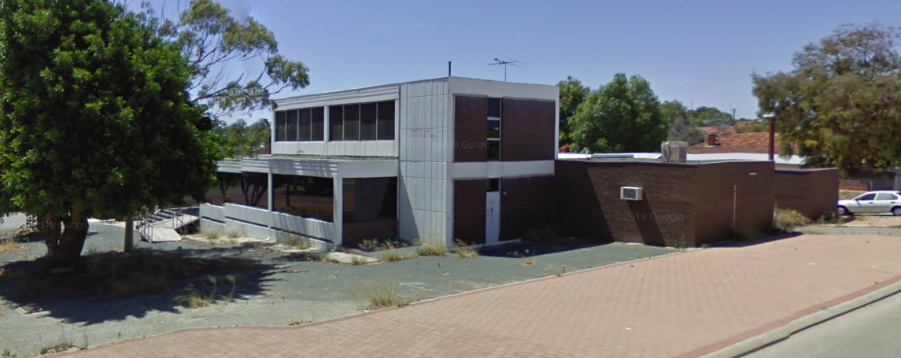
Figure 1. View of former post office from Straughair Street
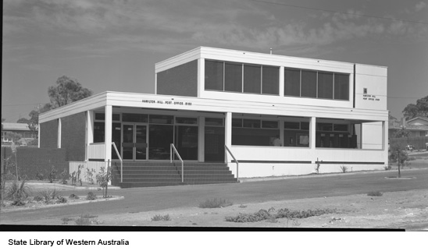

Figures 2 and 3. Hamilton Hill Post Office 1969
State Library of Western Australia 1969 photographs, 341182PD & 341183PD.
https://www.slwa.wa.gov.au/images/pd341/341183PD.jpg
https://www.slwa.wa.gov.au/images/pd341/341182PD.jpg

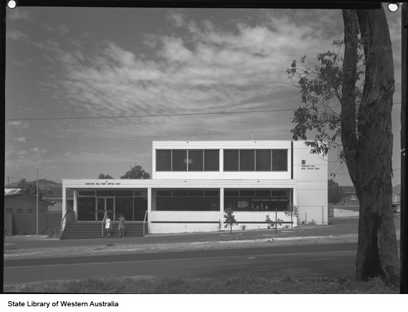

Apperley, R, R. Irving and P. Reynolds. (1989) Identifying Australian Architecture: Styles and Terms from 1788 to the Present. Sydney, Angus and Robertson, pp. 232-235.
Beverley Times, ‘W.A. Post office budget is $30.6million’Friday 27 September 1968, pp. 4
Beverley Times, ‘Post Office Achievements’ Friday 15 January 1965, pp. 4
Beverley Times, ‘W.A. Post office budget is $30.6million’Friday 27 September 1968, pp. 4

